](file:///\\Users\naymaqadir\Documents\Digital\Enable%20-%20Performance%20Tracking%20Simplified%20\2022%20License%20Renewal\Office%20work\AppData\Local\Microsoft\Windows\INetCache\Content.Outlook\AppData\Local\Microsoft\Windows\INetCache\Content.Outlook\AppData\Local\Microsoft\Windows\INetCache\atif.munwar\AppData\Local\Microsoft\Windows\INetCache\Content.Outlook\AppData\Local\Microsoft\Windows\INetCache\Content.Outlook\AppData\Local\Microsoft\Windows\INetCache\Content.Outlook\5ZWJBHBI\jazz.com.pk)

**TALKY (Smart Policy Guide)**

## Project Name: TALKY (Smart Policy Guide)

### Project Overview

The project involves productionizing an existing Python-based policy guide, designed to facilitate Policy QnA for the entire organization. The Policy Guide aims to provide the following functionalities:

### Must-Have Requirements

1. **Multiple User Handling**: The Policy Guide must support concurrent interactions with multiple users, with a focus on maintaining performance and responsiveness.
2. **24/7 Availability**: The Policy Guide should be operational 24/7 to meet user needs at any time, with automatic failover and recovery mechanisms.
3. **Integration with Peoplehub/App**: Seamless integration with Peoplehub/App, the organization's website, for user accessibility, including single sign-on (SSO) integration for a unified user experience.
4. **Chat History and Response Logging**: All user interactions and bot responses will be stored securely in a database, and access logs should include timestamps, user IDs, and the content of conversations.
5. **Access Management**: Implement a flexible and role-based permission system to control user and division access to the Policy Guide. Allow the assignment of permissions based on specific roles and responsibilities.

### High-Level Functionality Requirements

1. **Front-End Design**: Develop a user-friendly front-end interface for the Policy Guide to be embedded on the Peoplehub/App. Ensure that the design is responsive and compatible with various devices and browsers as per recommended Ui UX .
2. **Project IP Handling**: Ensure that intellectual property security measures are in place. Collaborate with the People Analytics team to create APIs that manage multiple Policy Guide sessions securely without sharing sensitive information.

### Additional Relevant Details

1. **Content Management**: Implement a content management system (CMS) that enables easy updates and additions to the Policy Guide's knowledge base, ensuring that it stays up-to-date with the organization's documents.
2. **Scalability and Load Balancing**: Design the architecture to be scalable to accommodate increased user load and implement load balancing to distribute traffic effectively.
3. **Security Measures**: Implement robust security measures, including data encryption, secure API endpoints, and compliance with data protection regulations such as GDPR, to safeguard user data.
4. **Error Handling and Logging**: Develop error handling mechanisms and comprehensive logging to track system performance and diagnose issues quickly.
5. **User Training and Support**: Provide user training materials and a support system to assist users in making the most of the Policy Guide.
6. **Analytics and Reporting**: Record Data for all the interaction with user that will be used for analytics and reporting to track usage patterns and gather insights for continuous improvement.

## Design Ideas

These are the design ideas for Development team to get started on TALKY (Smart Policy Guide). These screenshot are just for the Design idea.

Logo in the bottom right of the will be replaced with the Logo that will be shared with Branding Team.

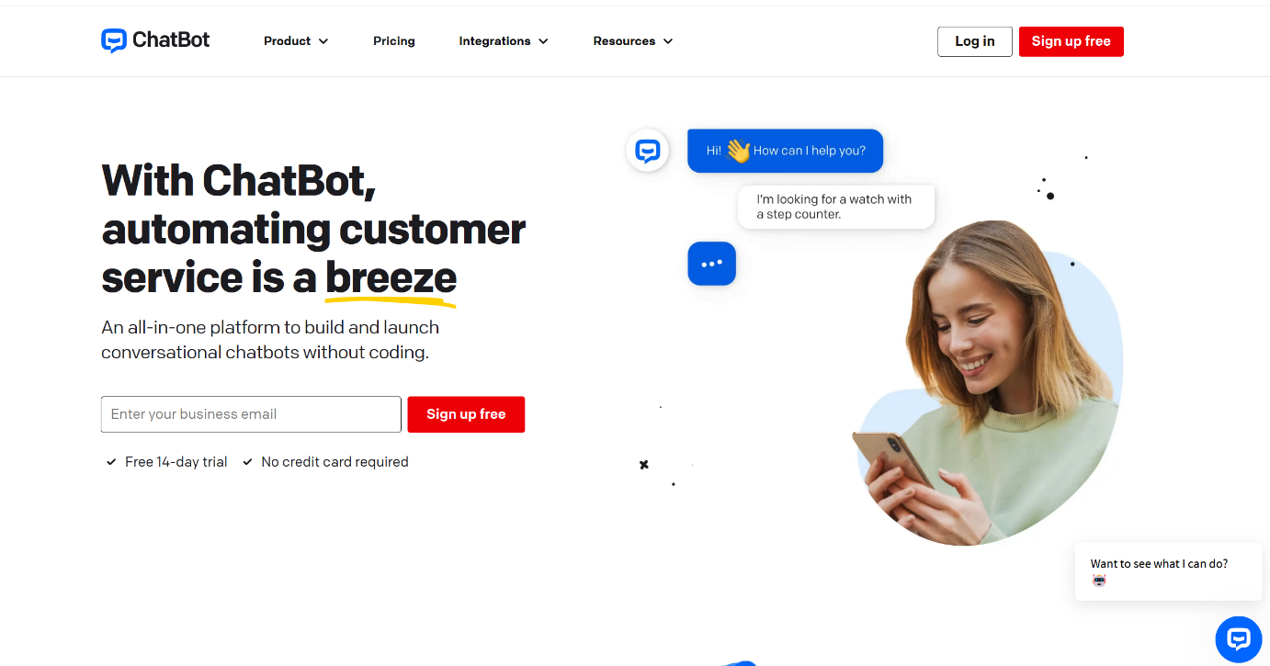

This is the Design idea for Chat window that will pop up when logo(in the bottom right corner will be clicked.

